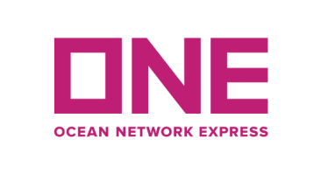
Ocean Network Express (India) Private Limited.
CIN: U63030MH2017FTC299547

3rd Floor, A Wing, Fulcrum, Sahar Road, Hiranandani Business Park,
Next to Hyatt Regency, Andheri (E), Mumbai-400 099,
Tel: +91 22 62153600 Fax: +91 22 62153601
Website: www.one-line.com

Advisory NPI Service: Cut off details for M.V. MAERSK PUELO V 0628E at GTI terminal,
Nhava Sheva. (Including Export Cut off)

Customer Advisory # MUM/2026-2027/353

Date: 09th July 2026
Dear Valued Customers,

Please be advised that Vessel M.V. MAERSK PUELO Voyage 0628E under NPI Service was delayed and is expecting to berth Nhava Sheva on 13th July 2026. We will keep you informed if there is any further change in the above given ETB.

Please note Export cut off for Dry & Reefers ex Nhava Sheva (GTI Terminal)
Gate Opening for Dry containers | 10.07.2026 / 06:00 Hrs.
Gate Opening for Reefer containers | 12.07.2026 / 06:00 Hrs.
Gate Closing (CY cut off) | 14.07.2026 / 06:00 Hrs.
Final DG scan copy cut off to booking team | 11.07.2026 / 06:00 Hrs.
Final DG hard copy submission to NSA OPS | 11.07.2026 / 10:00 Hrs.
Via Submission (Online through below link only) | 14.07.2026 / 07:00 Hrs.
Shipping bill / VGM cut off | 13.07.2026 / 11:00 Hrs.
Shipping instruction cut off (AMS China) | 11.07.2026 / 10:00 Hrs.

Pls apply Form 13 only through ODEX App.

PN: VIA (SSR) SUBMISSION APP is OPEN 10 HRS PRIOR TO GATE CUT OFF*.
Customers are requested to apply Via/SSR through the below link, which will be active for 1 hour only once the port cut off is over.

https://www.appsheet.com/start/e160cf38-279c-4983-8c0c-31b805f8c869#appName=VIAandSSRRequest-GCP-2278778&page=empty

ONE would like to take this opportunity to thank you for your continual support and for trusting your valuable business to ONE. Should you have any questions or concerns, please contact your sales account representative or Customer Service desk for additional information.

Request you to please submit Complete SI to avoid duplication on work.

For, Ocean Network Express (India) Private Limited.

Authorised Signatory

